Lab Exercise 2- Working with Git Reset
Lab Exercise: Git Reset
This lab exercise will guide you through the usage of the git reset command in various scenarios. The git reset command is used to undo changes in the Git history, working directory, or staging area. There are three main modes: soft, mixed, and hard.

Objective
- Learn how to use git reset to modify the commit history, unstage files, or discard changes.
- Understand the differences between --soft, --mixed, and --hard reset modes.

Prerequisites
- Install Git on your system.
- Set up a Git repository:
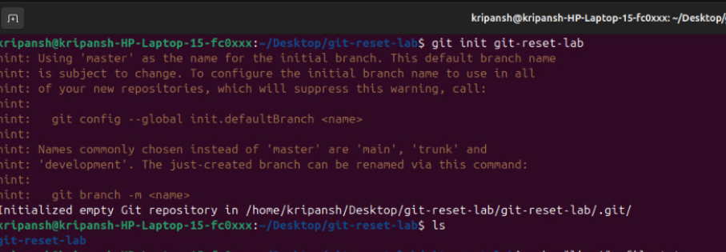

Steps
1. Set Up the Repository
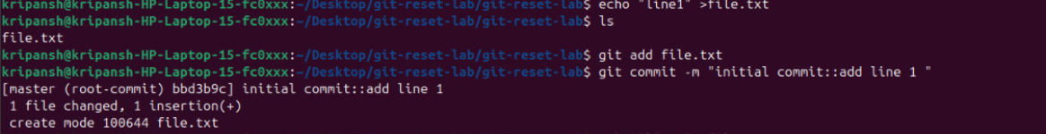
- Create and commit an initial file:

- Add a second change:

- Add a third change:
- Check the commit history:
2. Use git reset --soft
This mode moves the HEAD pointer to an earlier commit but keeps the changes in the staging area.
- Reset to the second commit:

- Check the commit history:
- Verify the staged changes:

Output:
- If needed, re-commit the changes:

3. Use git reset --mixed
This mode moves the HEAD pointer and unstages the changes but keeps them in the working directory.
- Reset to the first commit:
- Check the commit history:
- Verify the changes in the working directory:
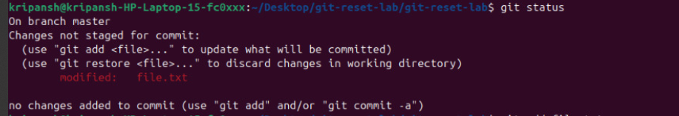
- If needed, stage and re-commit:

4. Use git reset --hard
This mode moves the HEAD pointer and discards all changes in the staging area and working directory.
- Reset to the initial commit:
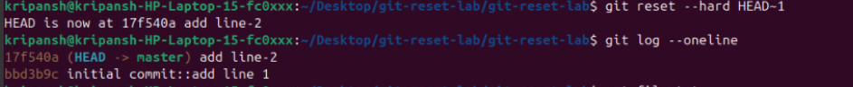
- Verify the working directory:

5. Use git reset with a Commit Hash
- Add some changes for demonstration:
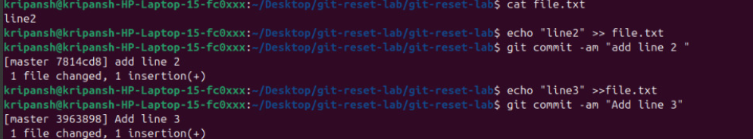
- Get the commit hash for the initial commit:
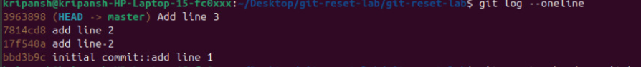
- Reset to the initial commit using the hash:
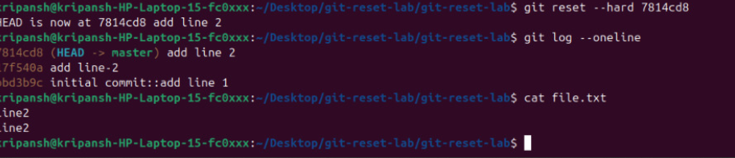

Git Reset, Revert, and Reset Modes

1. Git Reset & Revert Commands
Command | Purpose | Key Points / Use Cases
git revert <commit-hash> | Creates a new commit that undoes the changes of the specified commit without changing history | - Safe for shared branches  - Good for collaborative projects
git reset <commit-hash> | Moves the HEAD to the specified commit (different effects based on reset mode) | - Useful for rewriting local history  - Not safe to use on public/shared branches without caution

2. Git Reset Modes
Command | What It Does | Staging Area (Index) | Working Directory | Common Use Cases
git reset --soft <commit-hash> | Moves HEAD to the commit, keeps changes staged | ✅ Staged | ✅ Kept | - Redo last commit but keep changes staged  - Combine commits with git commit --amend
git reset --mixed <commit-hash> | Moves HEAD to the commit, unstages changes, but keeps files | ❌ Unstaged | ✅ Kept | - Undo commit but keep code changes to edit and recommit
git reset --hard <commit-hash> | Moves HEAD to the commit, discards all changes | ❌ Cleared | ❌ Discarded | - Reset repo to a clean state  - WARNING: Destructive, data may be lost

3. Examples
Task | Command Example
Undo the last commit but keep changes staged | git reset --soft HEAD~1
Undo the last commit but keep changes unstaged | git reset --mixed HEAD~1
Completely discard the last commit and all changes | git reset --hard HEAD~1
Revert a specific commit without rewriting history | git revert 123abc
Reset to a specific commit (e.g., abc123) and clean state | git reset --hard abc123

4. Key Tips
- Always check your status with `git status` after a reset.
- Use `git log --oneline` to find commit hashes easily.
- For destructive commands like `--hard`, consider creating a backup branch first:
git branch backup-branch

